Azure Monitor- Log analytics workspace

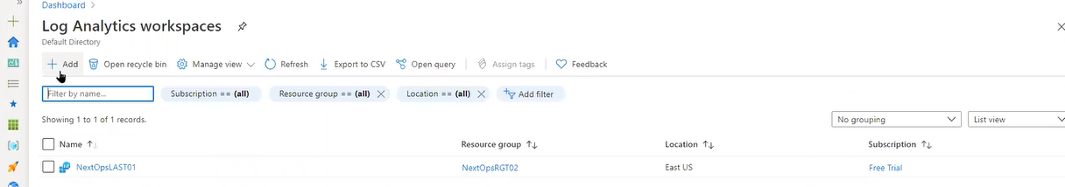

All resources coming data will be stored in log analytics workspace(Azure and Non Azure)

Azure machines directly we can on board to azure monitor services and for Non-Azure machines we need to use log analytics work space for on boarding

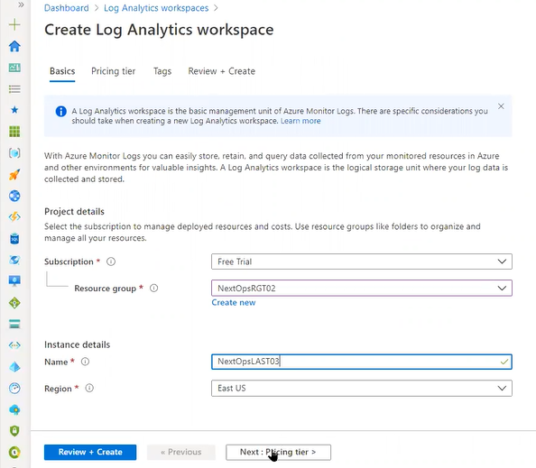

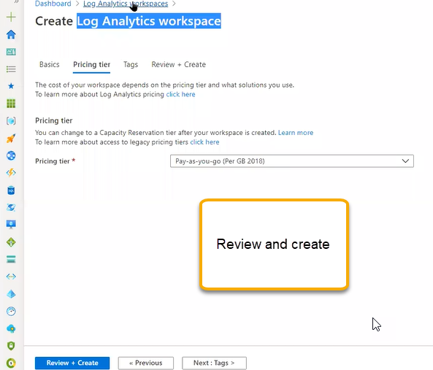

Pricing tier is per GB based

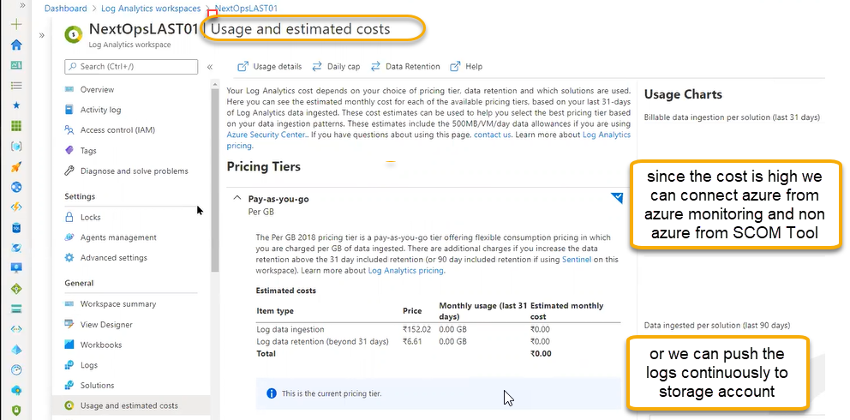

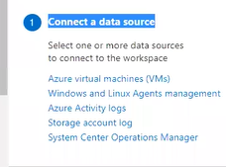

Using the queries we can extract the data

Agents Management : this is used for non azure machines we need to onboard either windows or linux

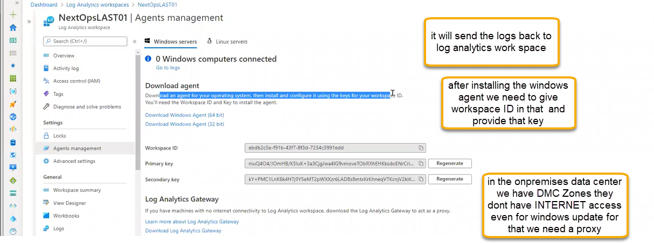

Log analytics gateway is one of the component where DMC machines present we need to install the particular server ( for outbound internet access ) that machines will be connected to workspace via gateway and sends the information

1. Open the Onpremises machine and download the windows agent. Just copy the agent link and paste it in the browser

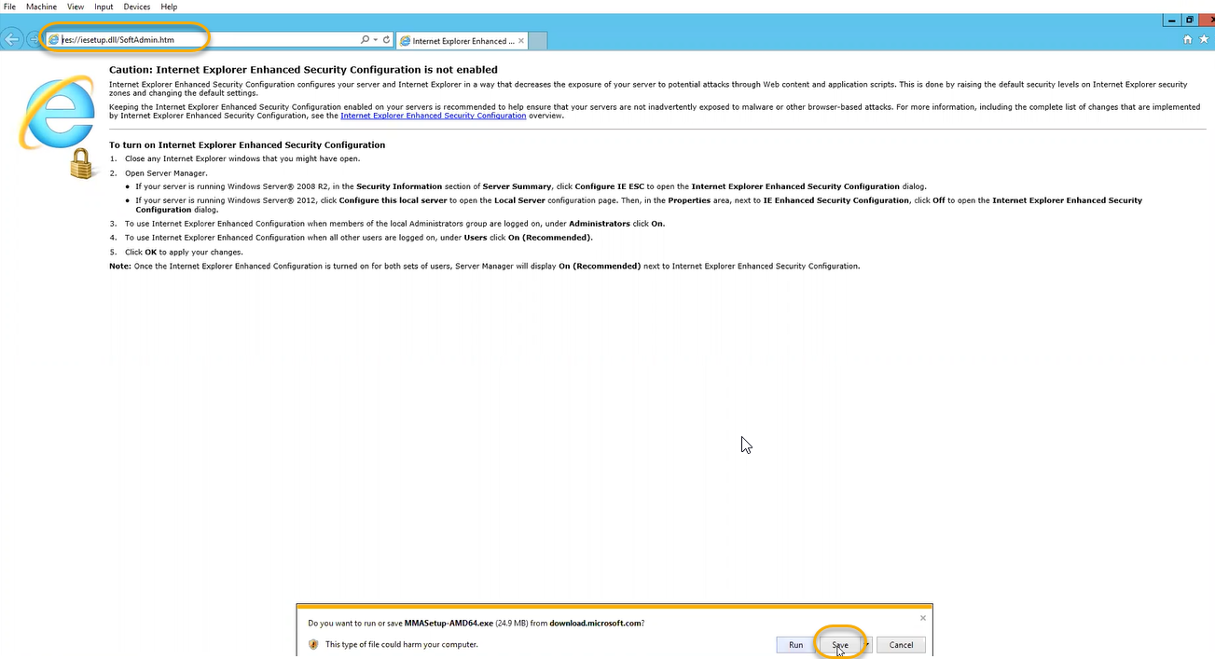

1. 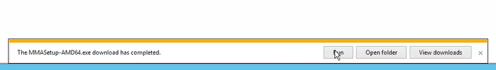
2. 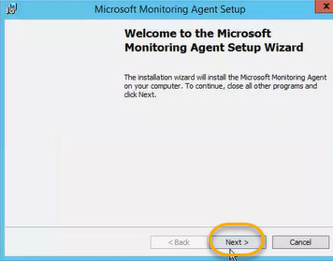
3. Click on > I agree > Next > Next >

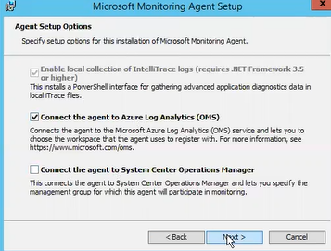

1. 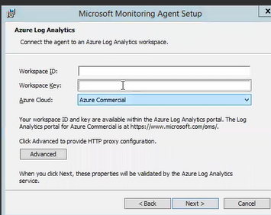
2. 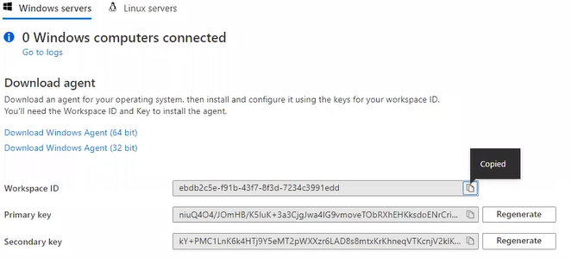
3. 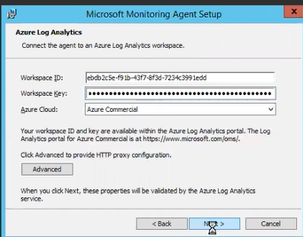
4. 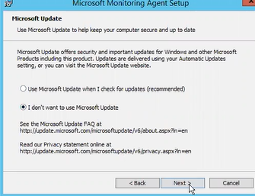
5. 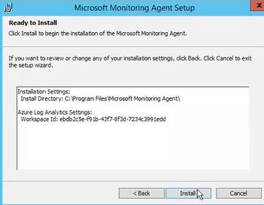
6. To install like this for 100 machines it will take so much time. For this at some point of administration like active directory we will join 100 machines through AD ( Active directory)

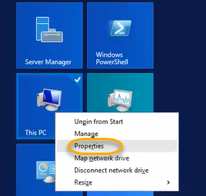

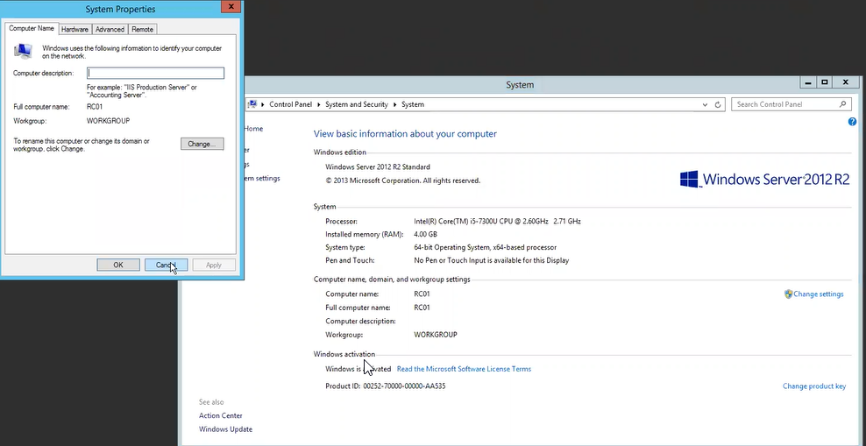

1. Active domain we will get membership if you install Microsoft agent in the AD it will detect all the computers and the same process will follow for SCOM
2. Scope Configuration

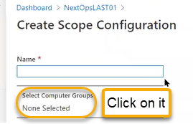

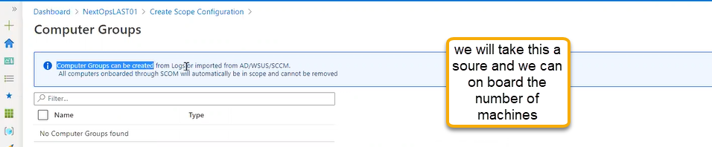if you want to connect to Azure directory then we need to sync to AD server so connected machines will show here

We check in the on premises if that service is running or not

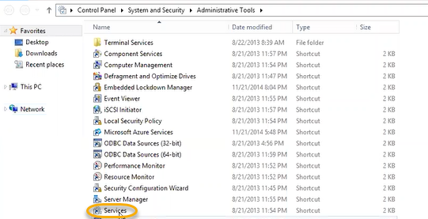

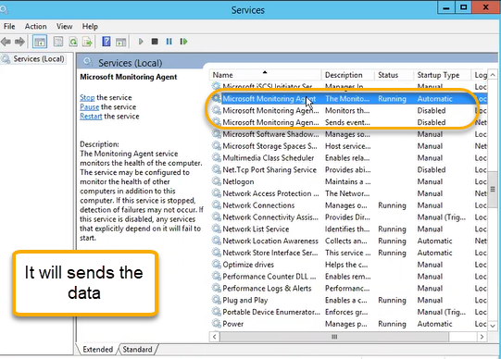

Advanced settings

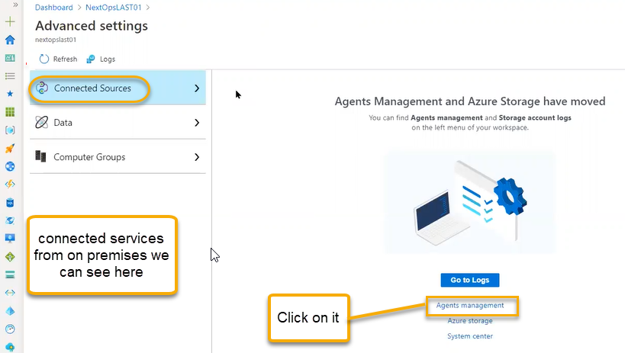

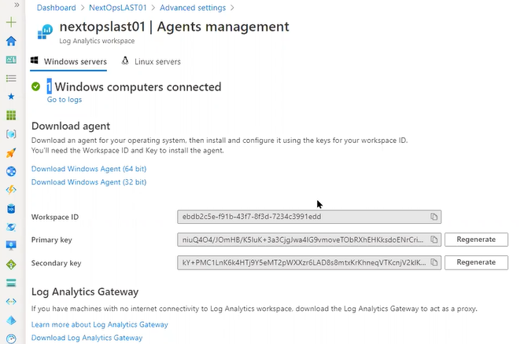

Using the agent management we can onboard on-premises machine or we can bring logs from azure storage

What kind of data we need to collect that we can see in the DATA Column

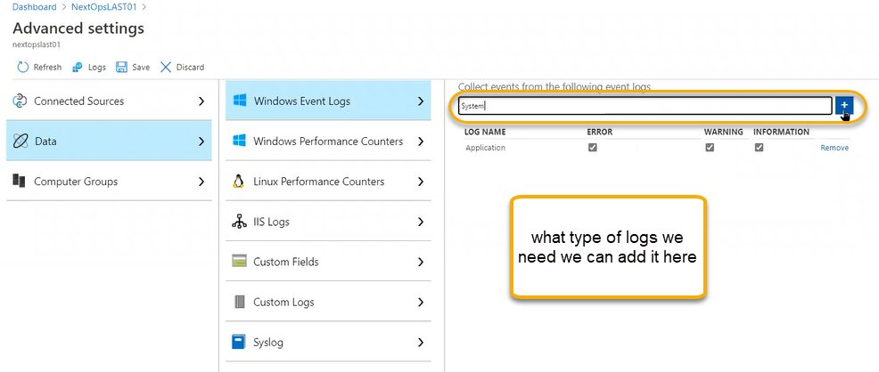

Event Viewer > On premises machine

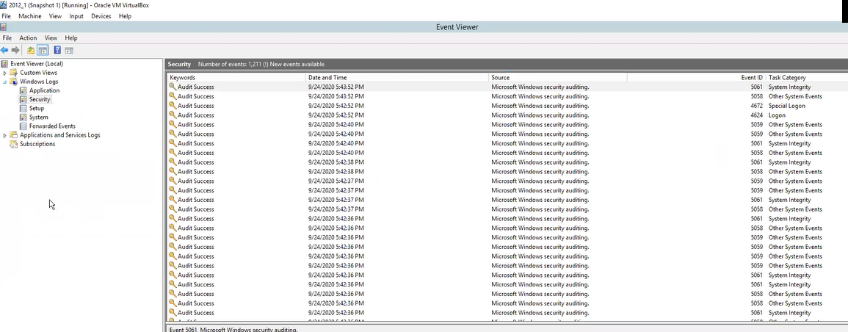

Performance counters

In the windows we have default option

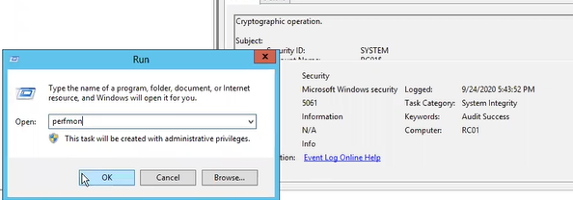

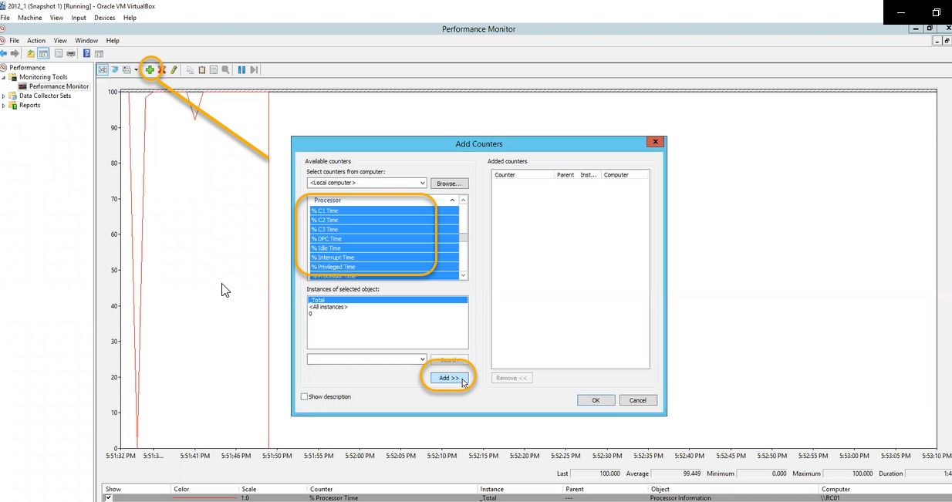

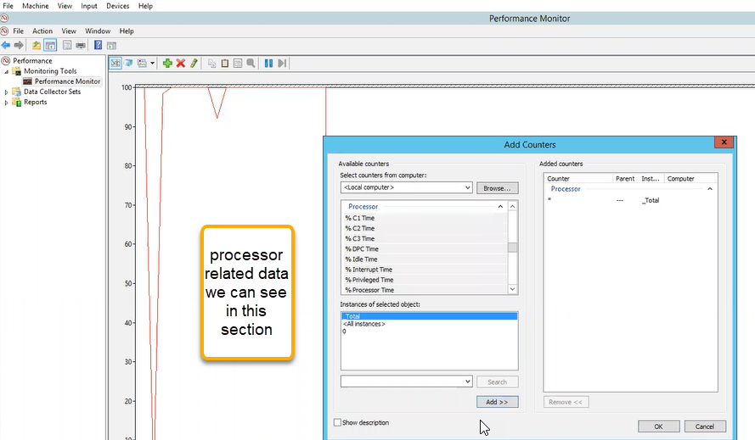

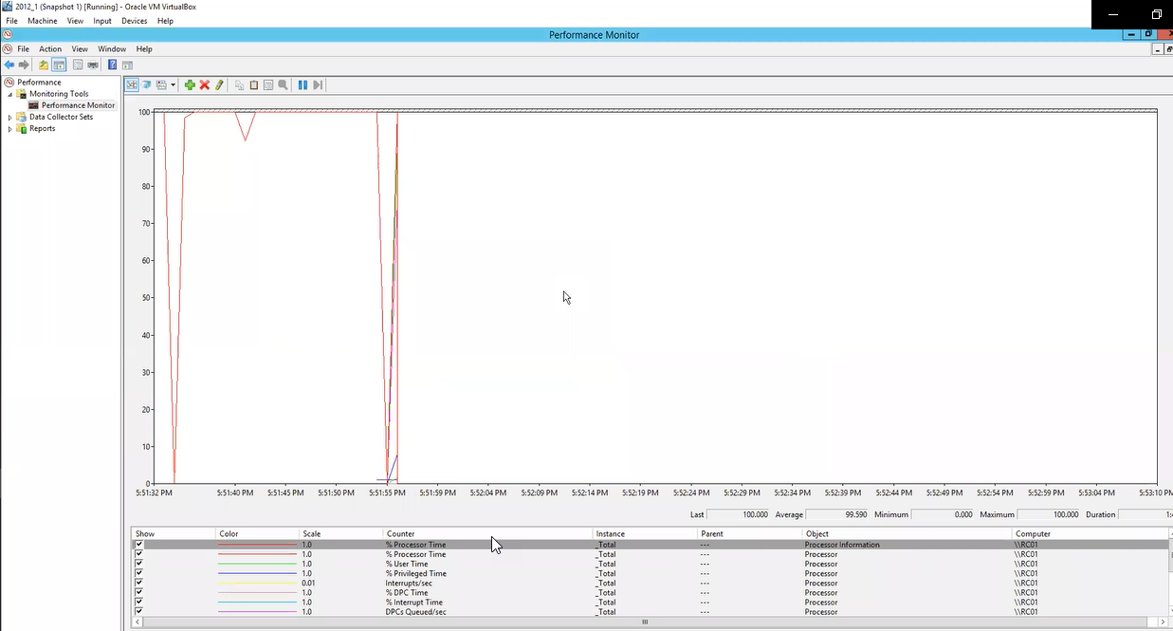

If you want to use this a sources in Azure

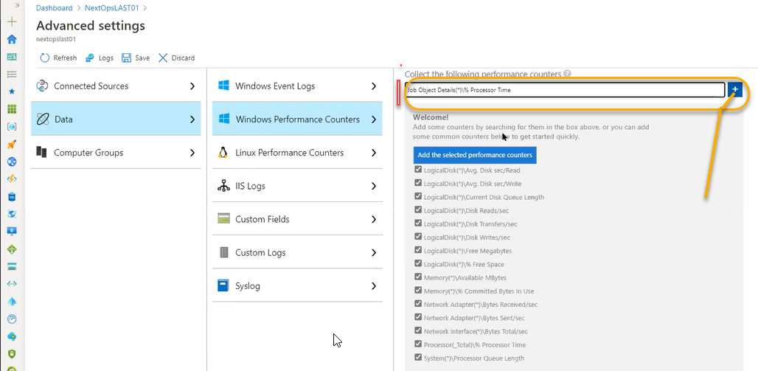

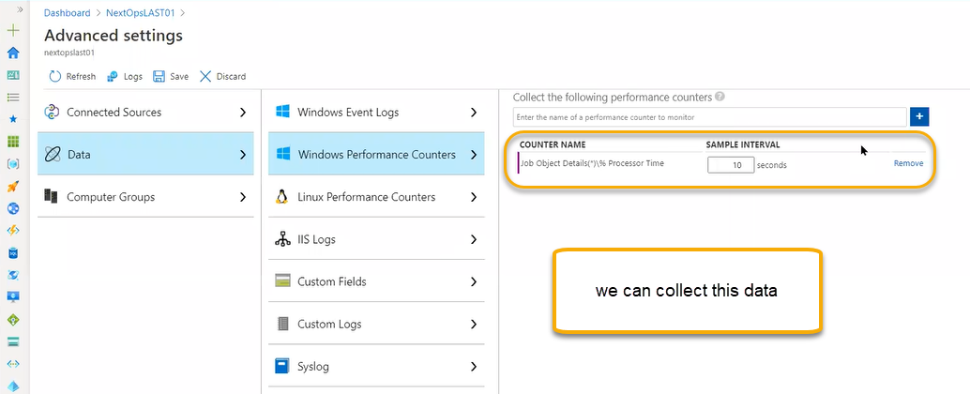

In the custom logs we can configure regarding the antivirus and we can join here

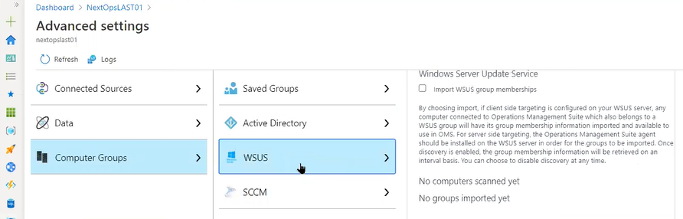

Work space summary

If you want to integrate the multiple third part solutions we can see in the overview

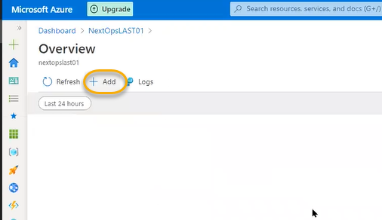

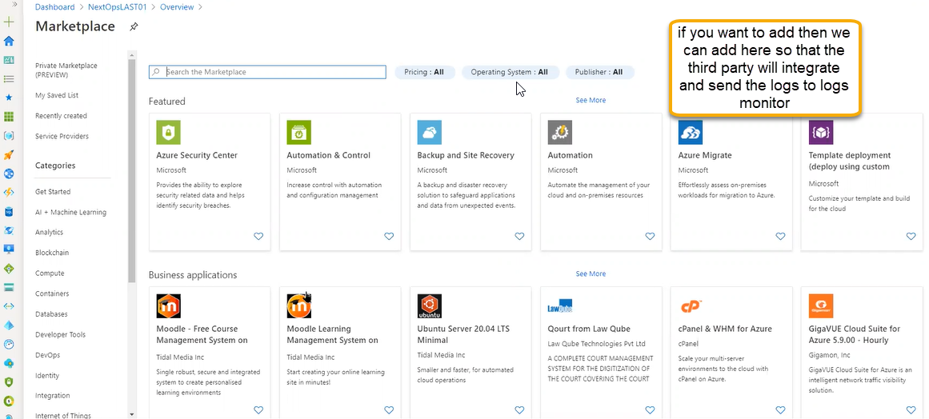

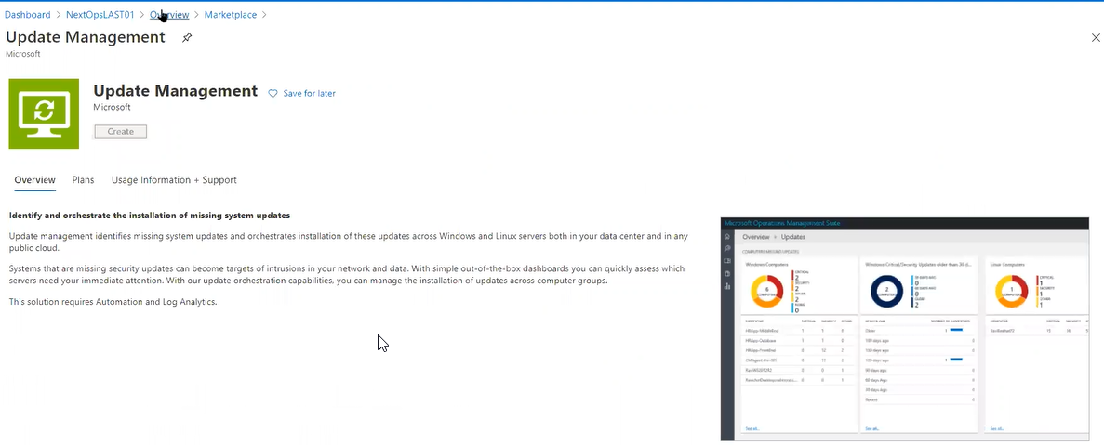

View designer or workbook: It is a kind of mechanism that supports dashboard if you want to customize it

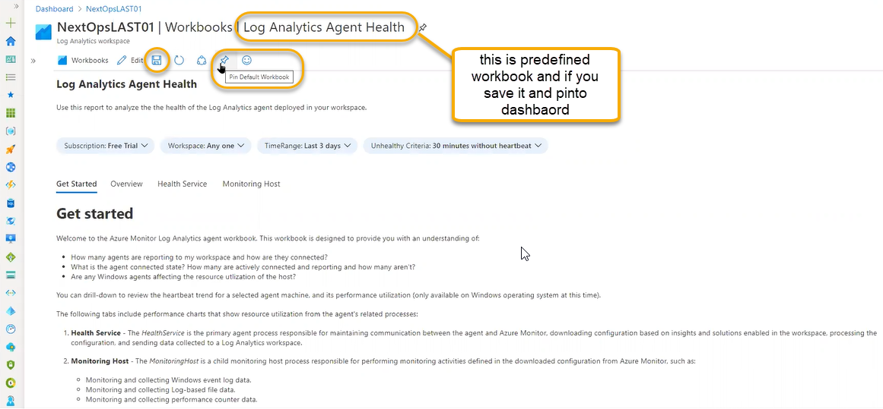

If you save it the below option will appear

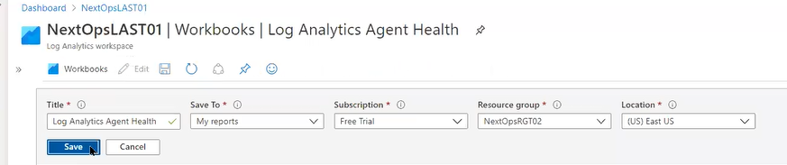

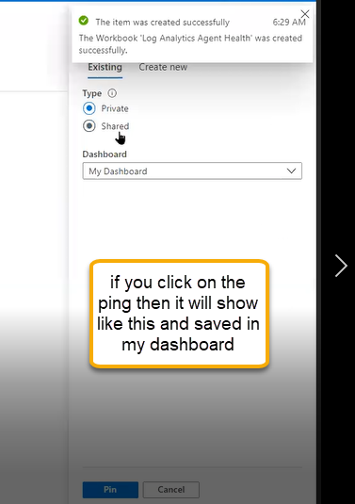

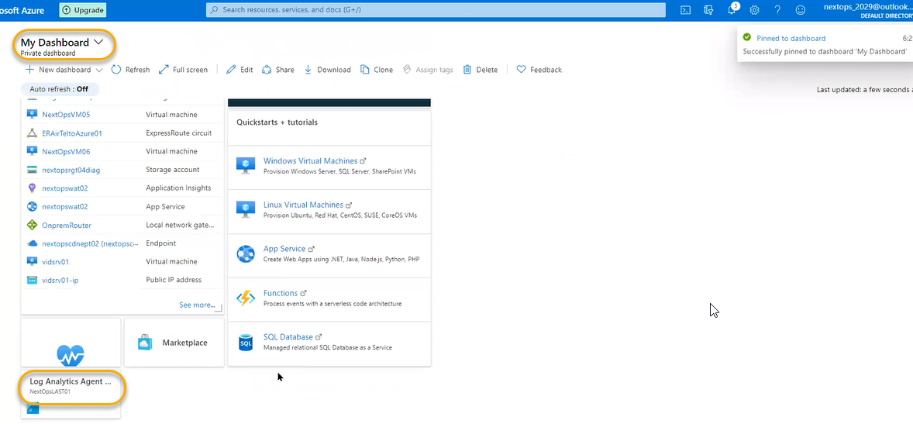

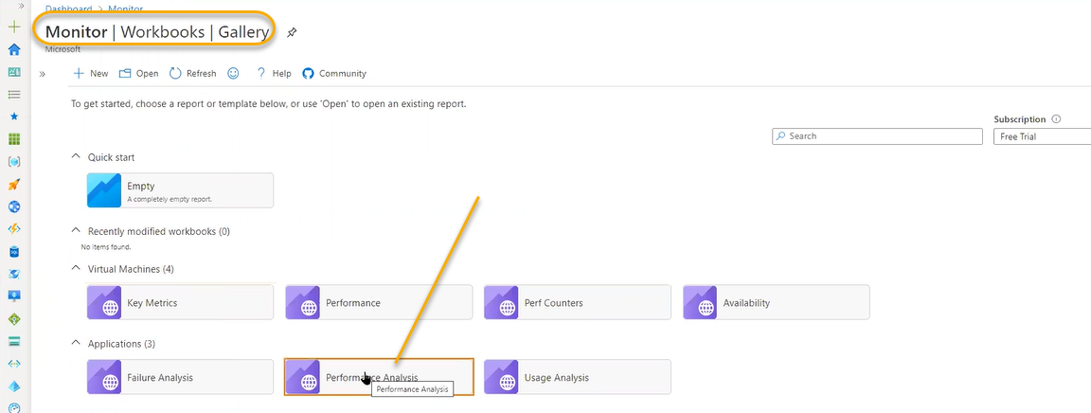

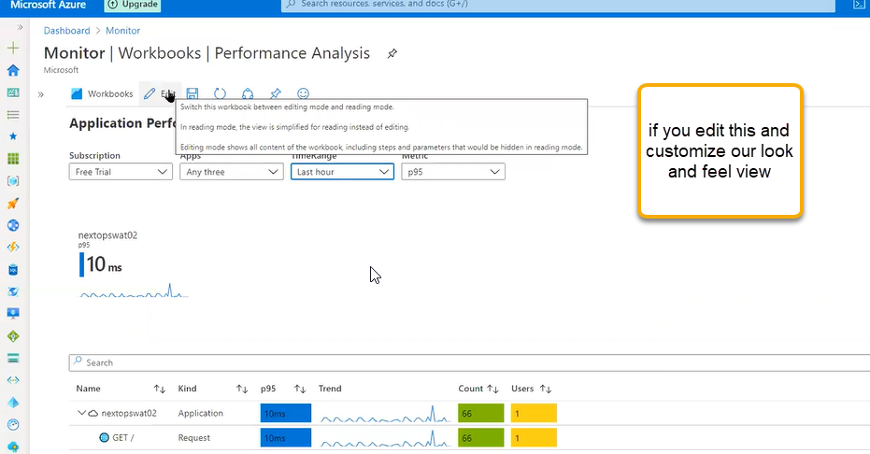

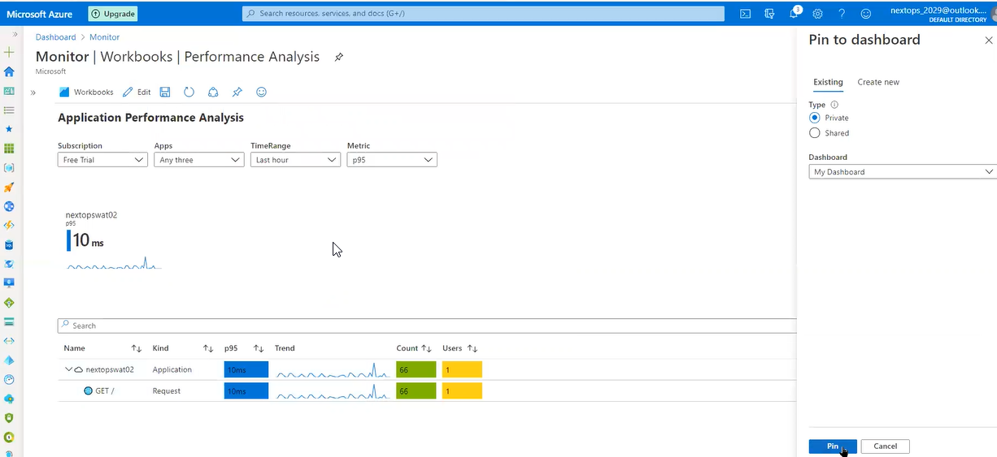

If you pin this we can see this workbook in the dashboard

We can create the empty workbook

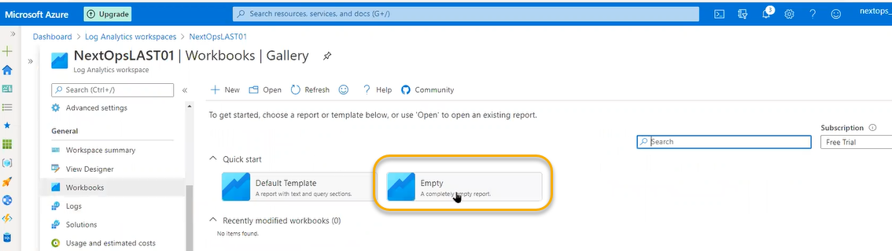

If you click on empty we can see the editing options

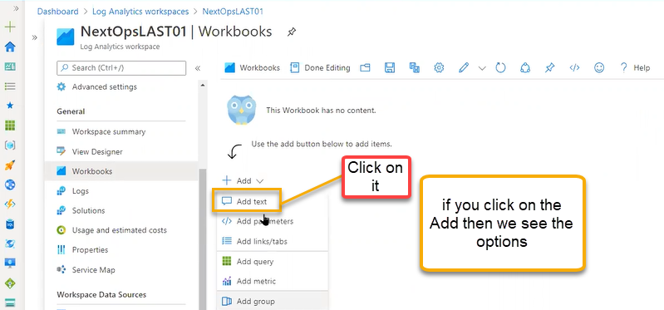

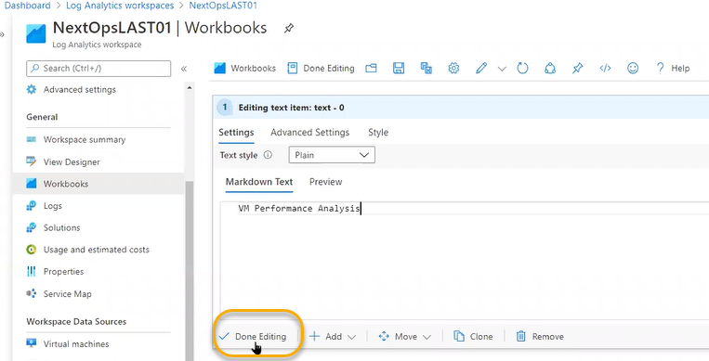

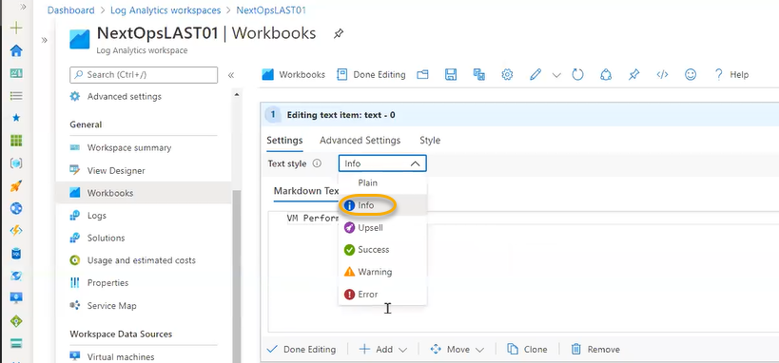

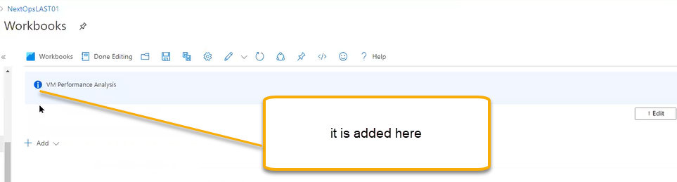

And then “Add metric”

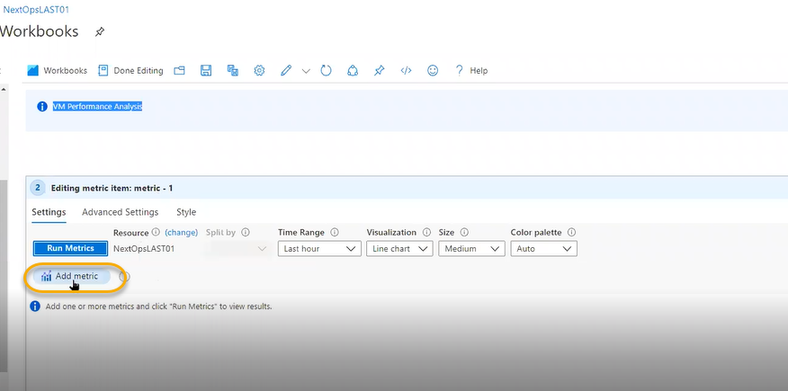

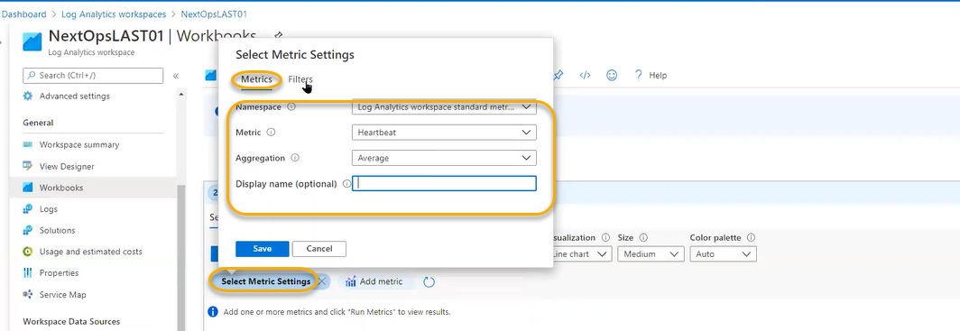

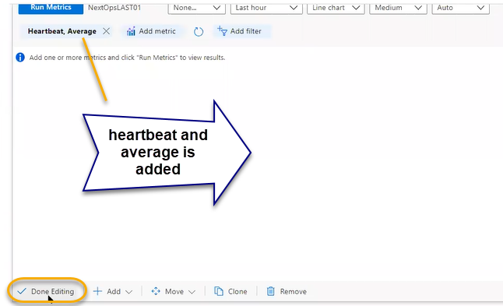

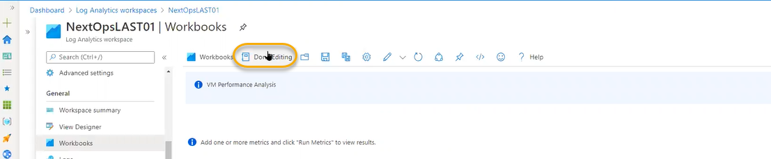

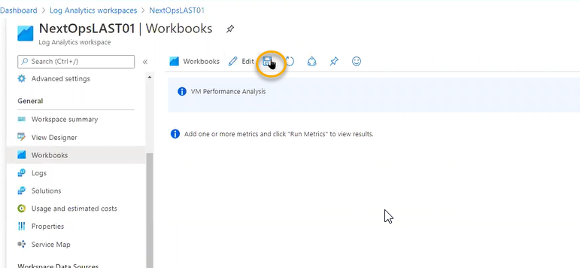

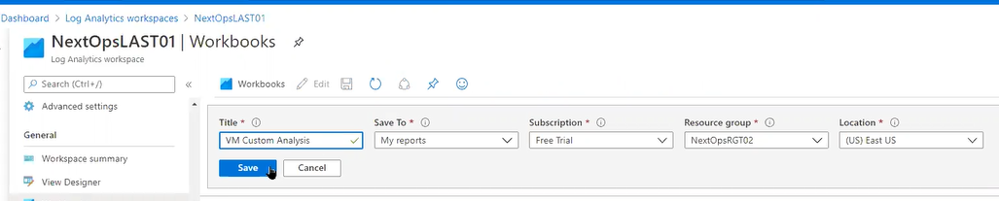

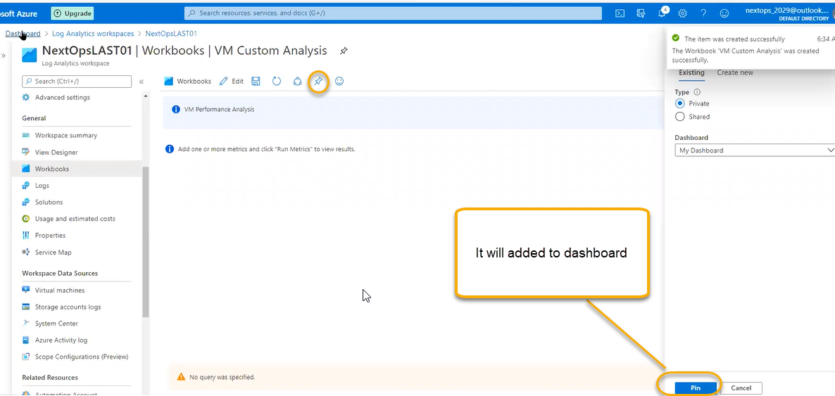

In the workbooks if we customized it then we can see the icons as user and if it is predefined we see like global icon

Logs

Is the main in the log analytics workspace and it is Splunk type of monitoring tool we will run the queries based on the queries we can analysis the outage on particular environment

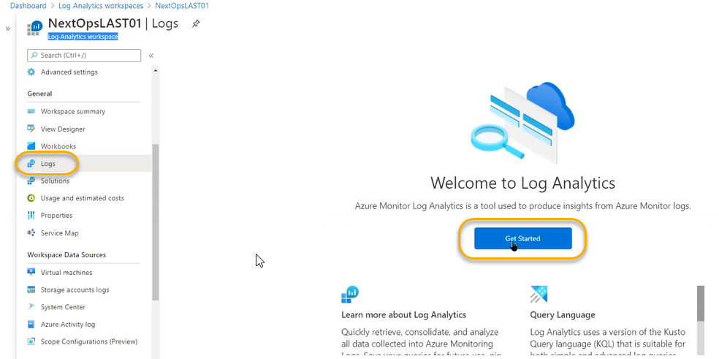

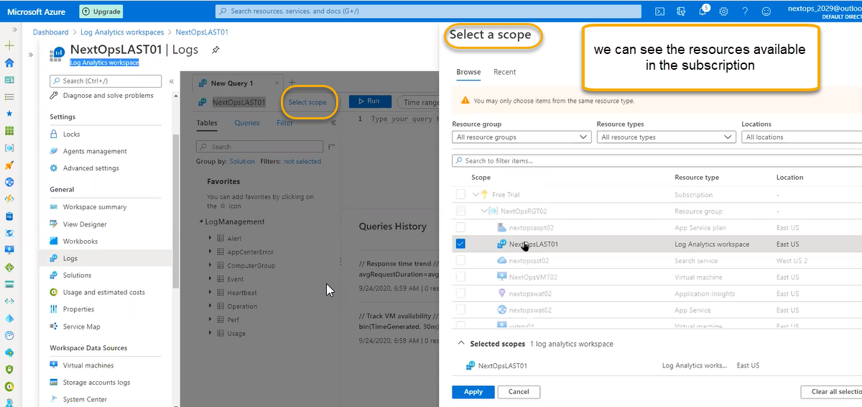

And in that resources we can add it and we can query it by using KQL. We can do the query by suing the query explorer

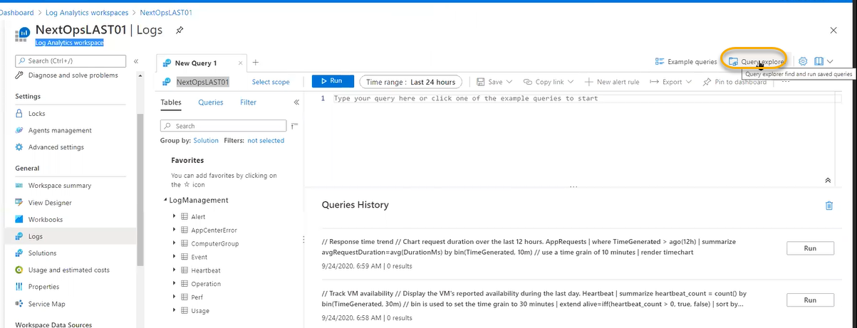

Or if you click on the example queries the below tab is applied

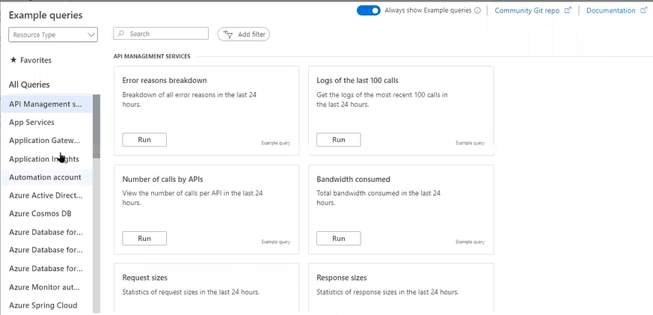

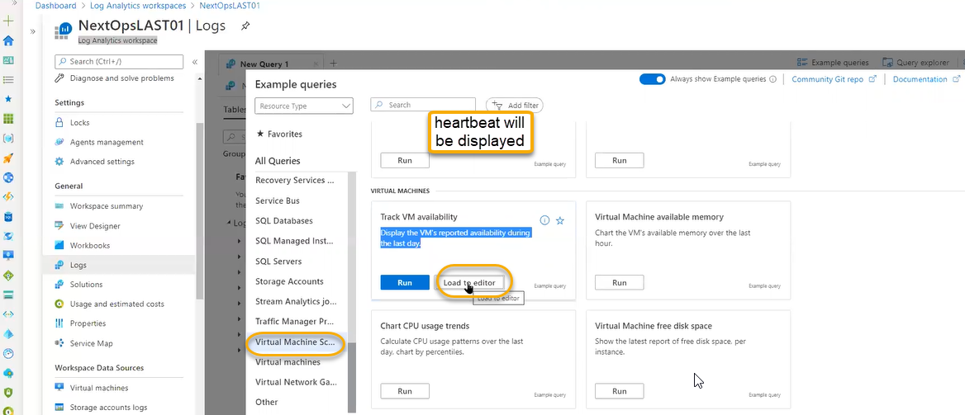

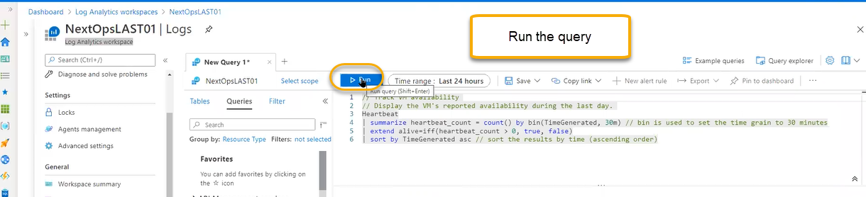

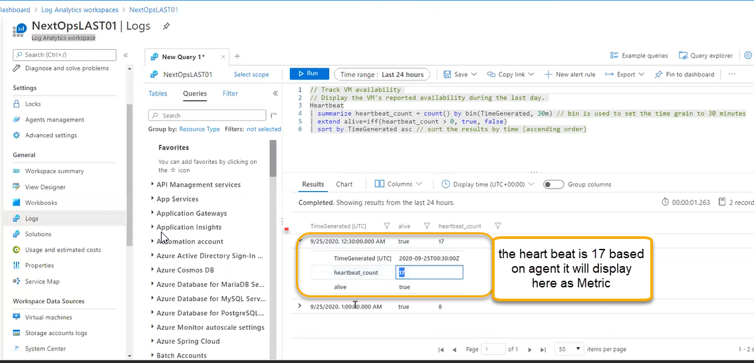

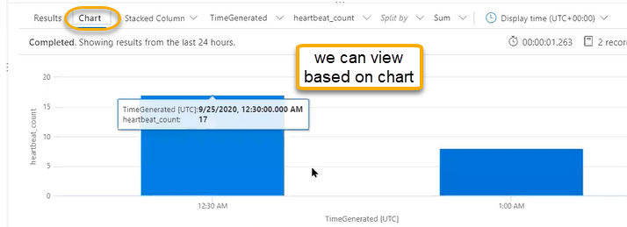

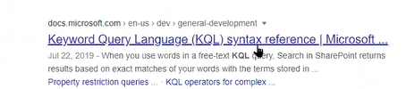

Solutions In the solutions we can onboard the on-premises from the workspace summary and we the same in the solutions tab

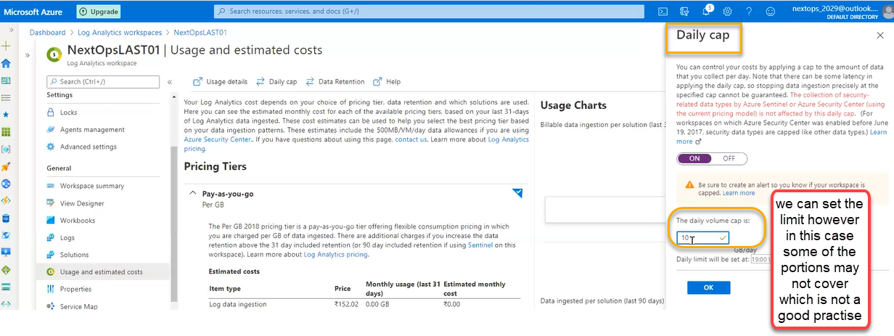

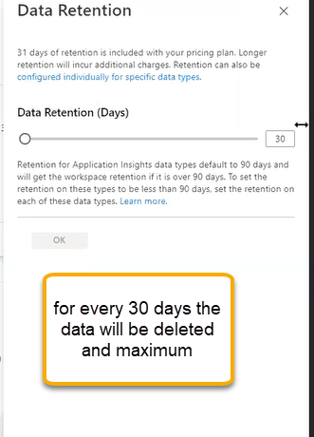

Service map

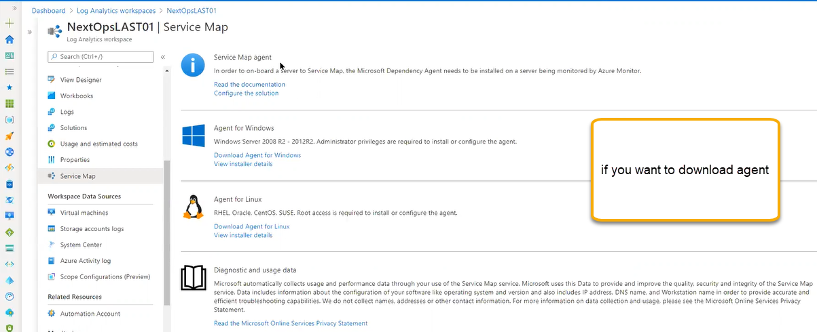

Workspace data sources where the data is collecting from this workspace

Virtual machines for onboarding the on premises we will use the agents management however azure machines will be directly connected to workspace and we see under the below page

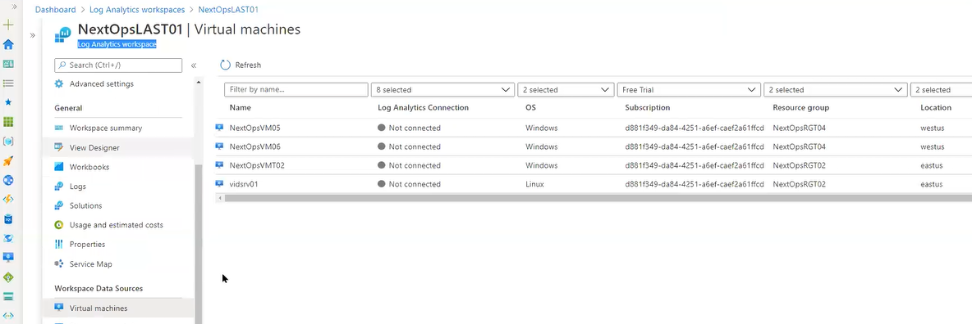

We can onboard the VM in the below one also

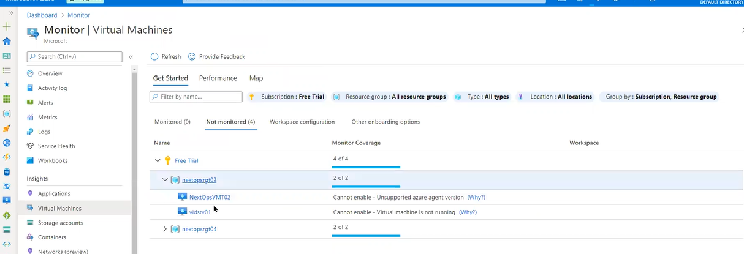

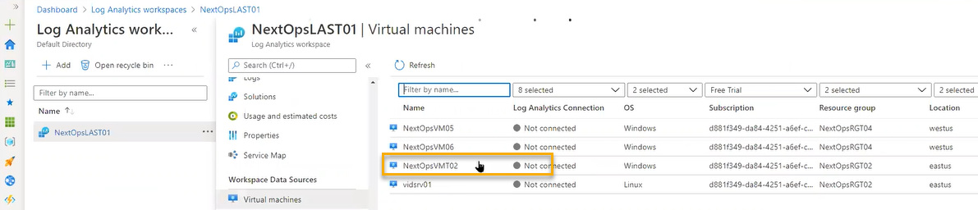

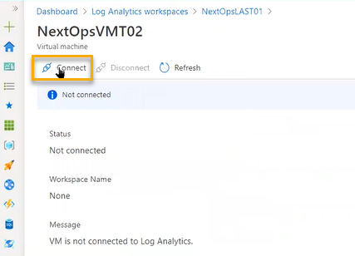

Storage Account Logs

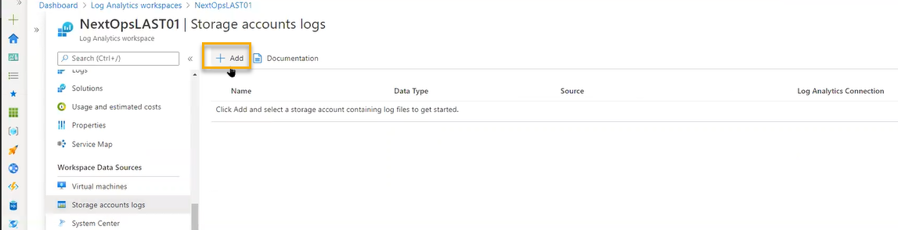

This diagnostics storage account if we create any VM we will select one diagnostics storage account in that saving data they can stored in tables data

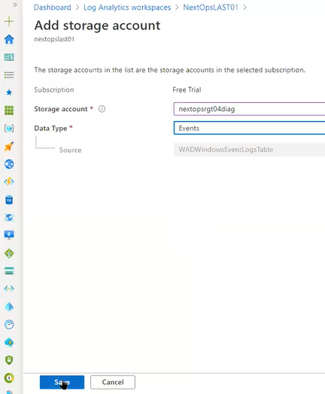

System center

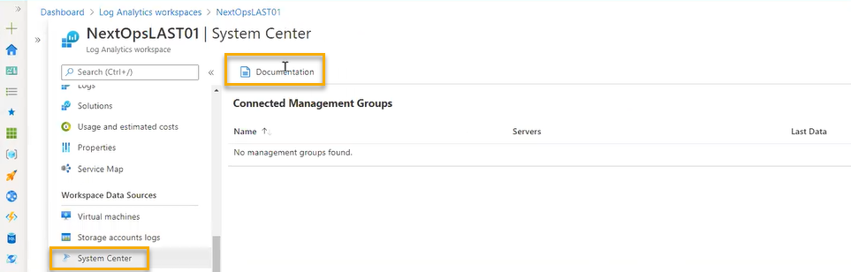

OMS connecter if we installed in on premises it will act as broker to Azure monitor

Machine collections can be pushed from this broker

We can see the same in the advanced settings

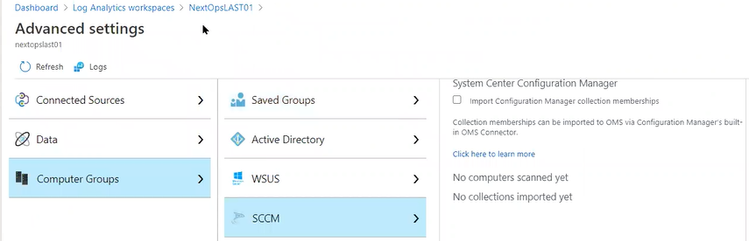

Azure Activity log

We can integrate our platform here.

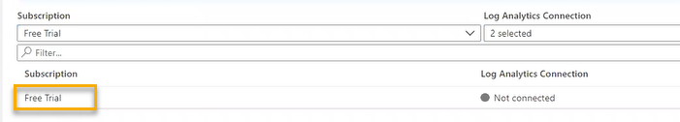

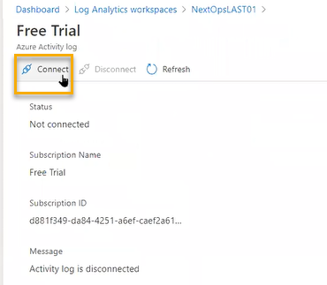co

Continuous export to log and can be preserved until we deleted

Automation Account

Log analytics workspace most of time can be connected to automation a\

If you want to automate in azure this is a single point, to schedule the job or execute the script in the set of machines we can integrate to the automation account

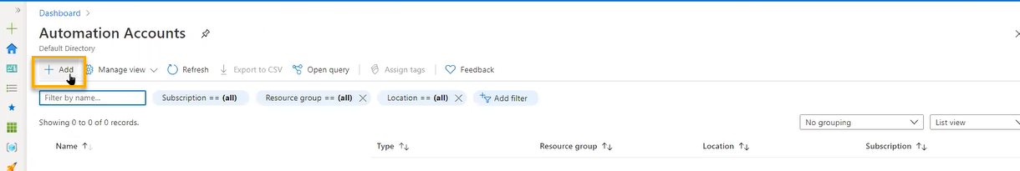

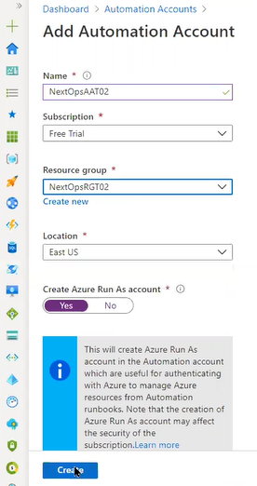

When the automation account is used for log analytics workspace to update management, Change tracking and start/stop during the off-hours by automation script in the powershell we can schedule and power on the VM

In the VMS we have an option for auto shutdown however we don’t have an option for up

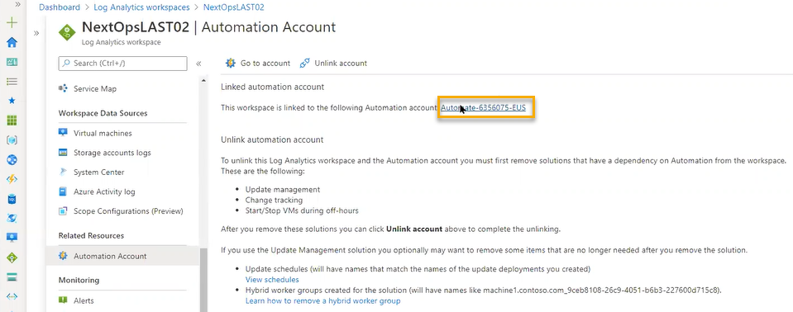

Configuration management

Inventory

A VM machine related automation we can see here

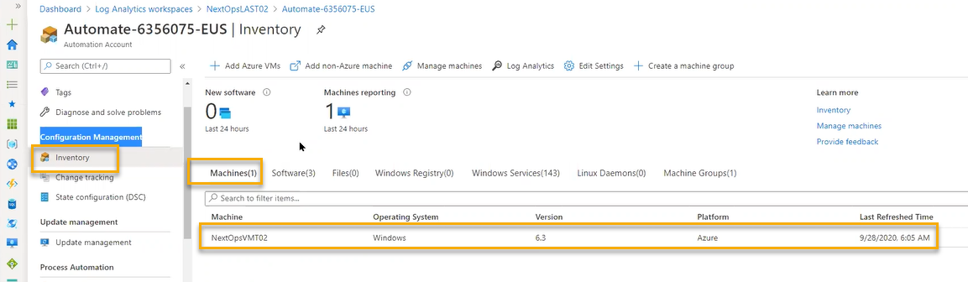

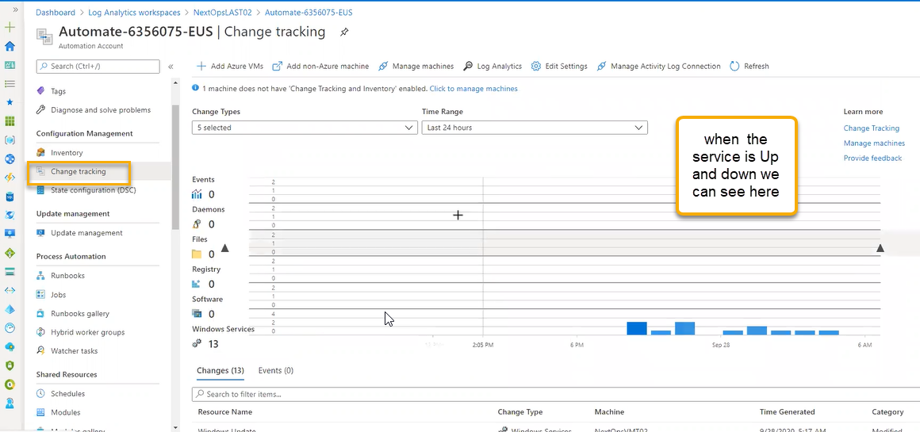

State configuration (DSC) : if you want to bring the machine to desired condition

We can use the PowerShell to bring to desired condition

Update management: We can use the automation to update the machine and schedule

We need to enable the services for the VM level through automation account it will connect to log analytics workspace

Auto power UP can be down by Runbooks

Which can be achieved by scripts

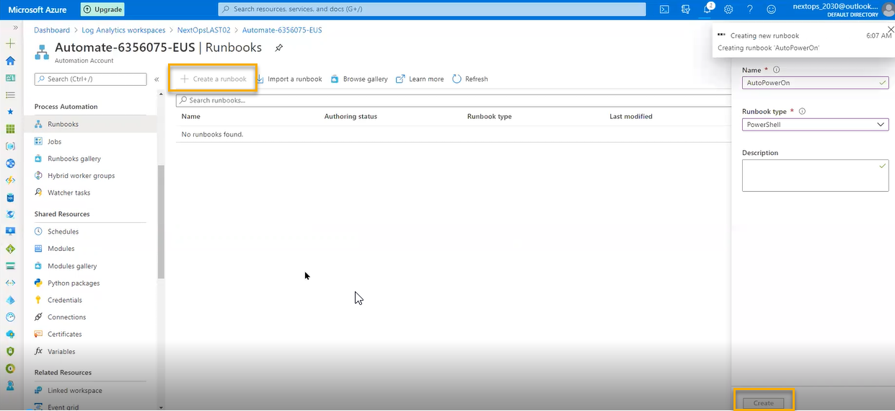

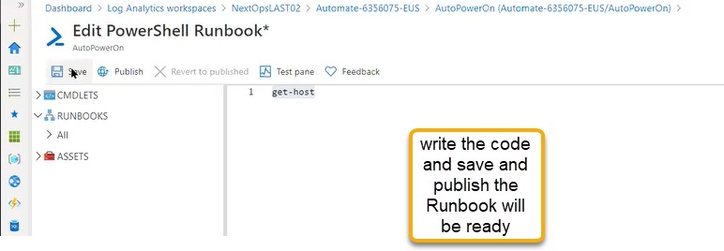

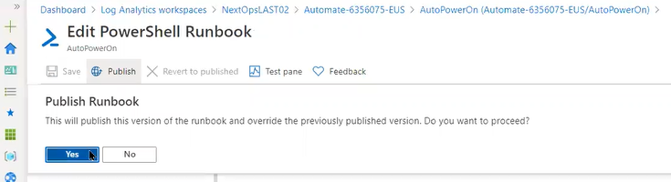

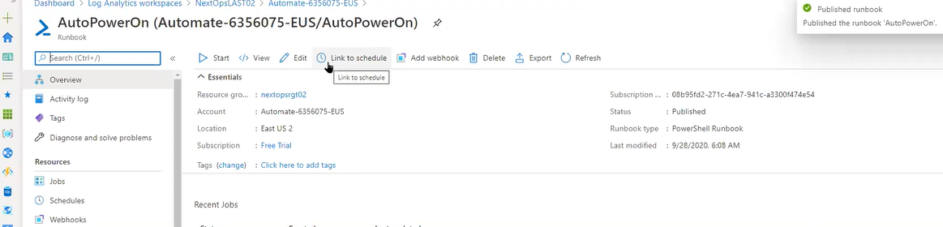

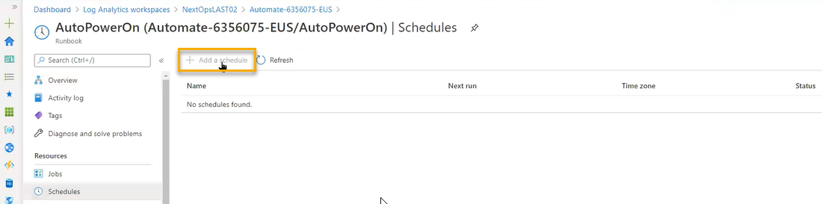

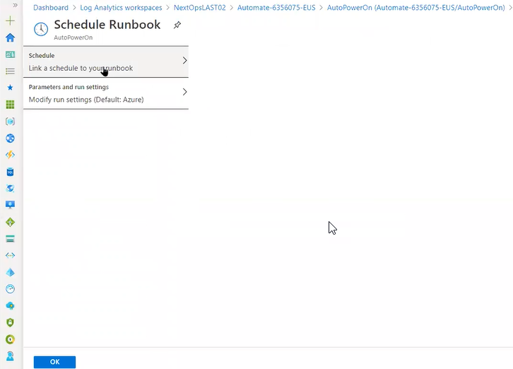

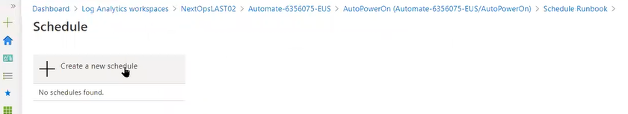

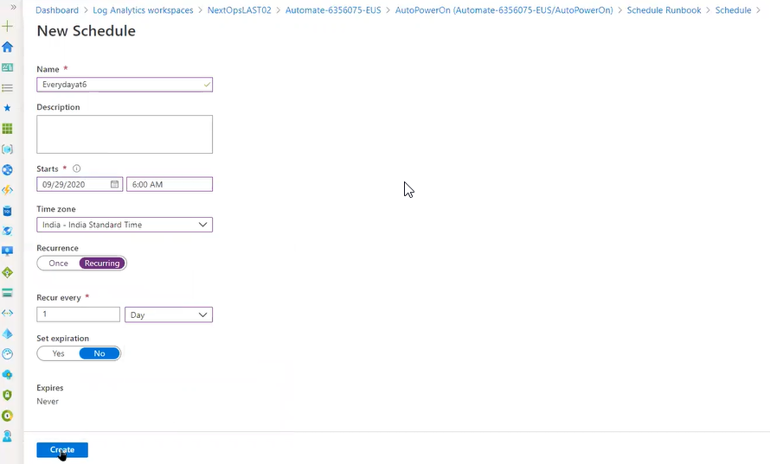

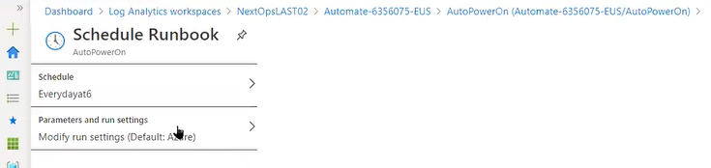

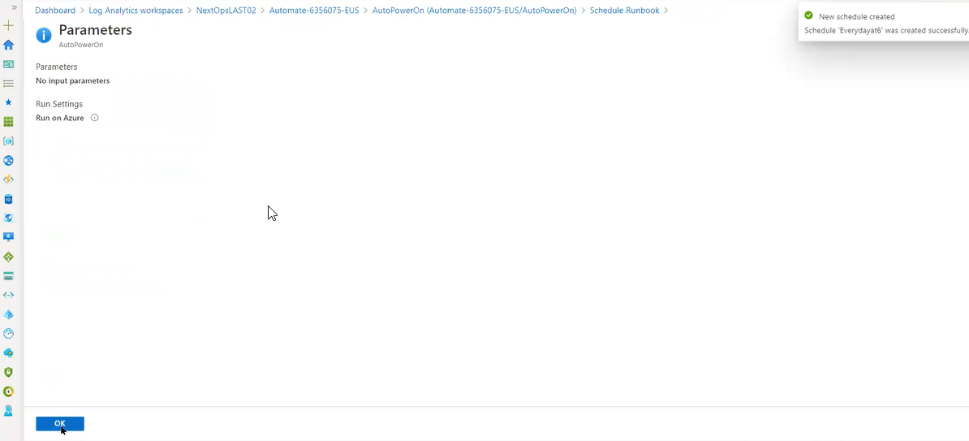

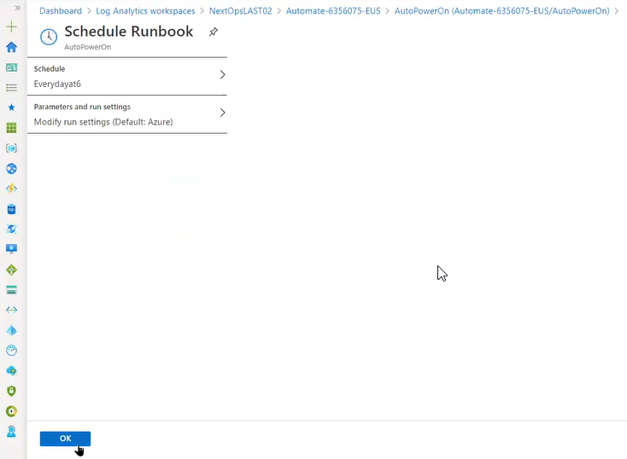

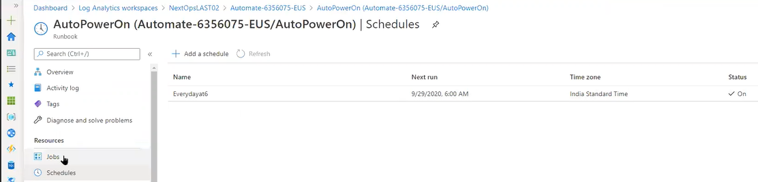

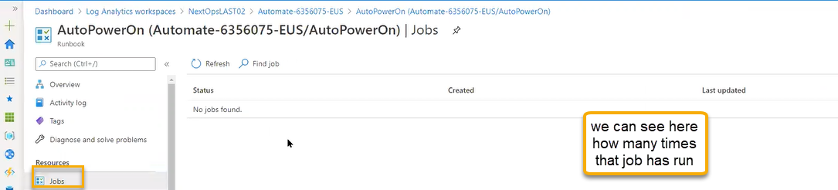

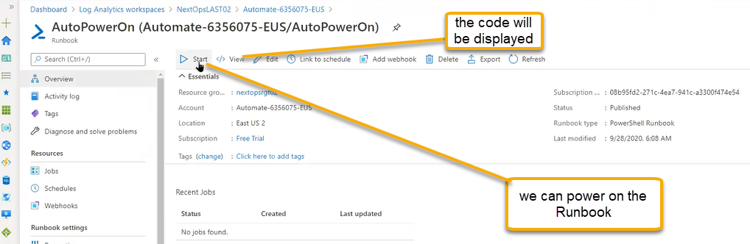

Shared Resources

If you integrate the automation with Azure devops in that devops we need to give access to Run books

Through Run books we can connect to devops

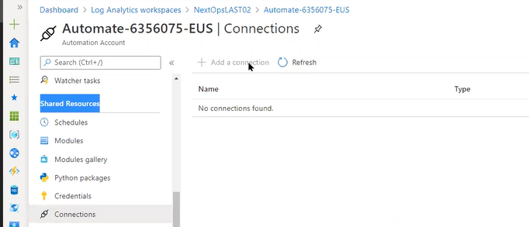

Tasks is a new feature which is adding for every resource which can trigger the automation regarding the billing

Log analytics > Workspace > Agents management > we can logs related for Non Azure and Azure

Insights

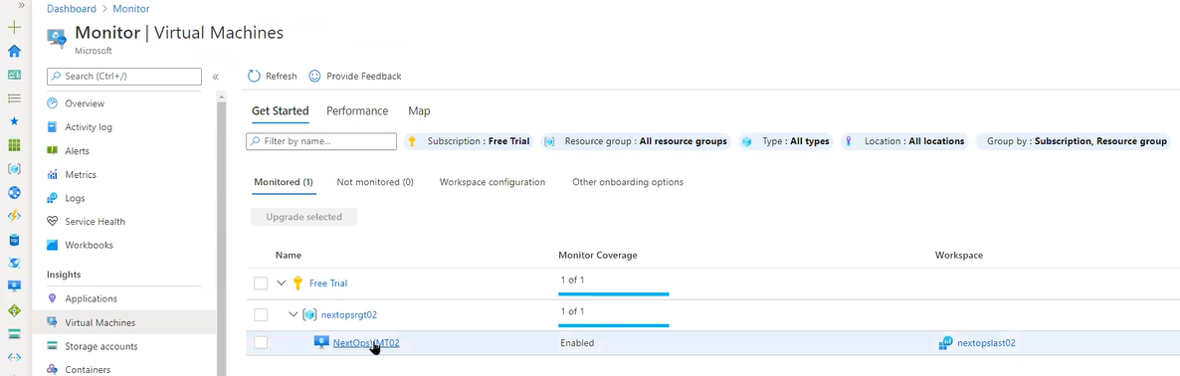

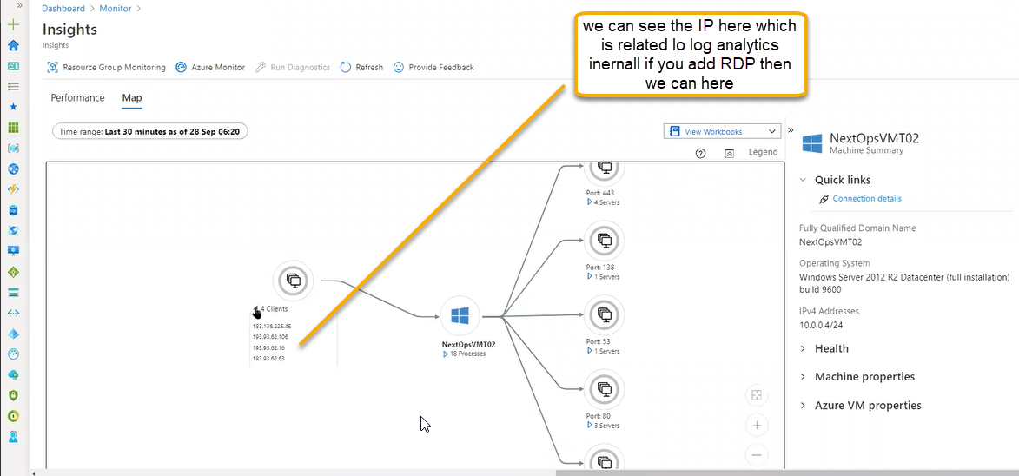

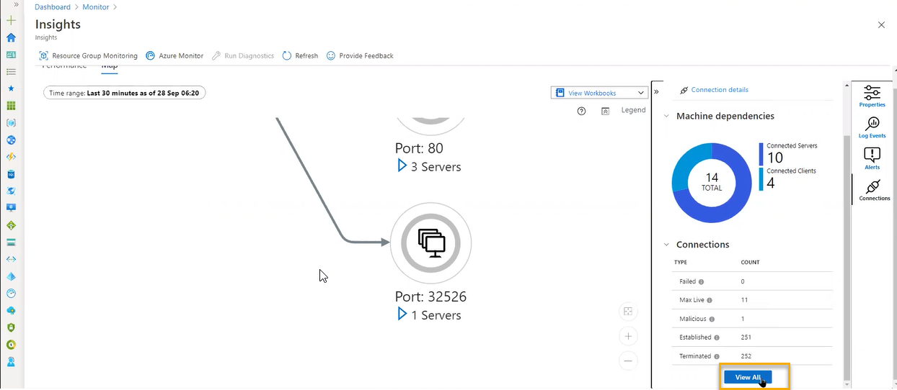

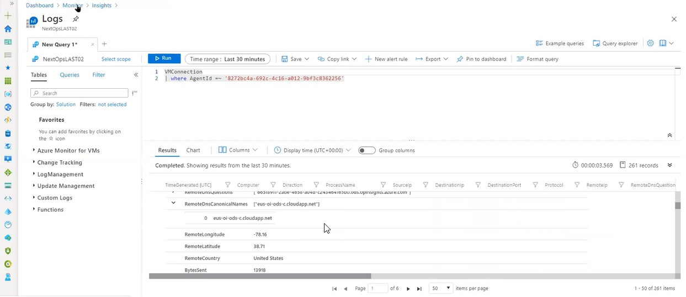

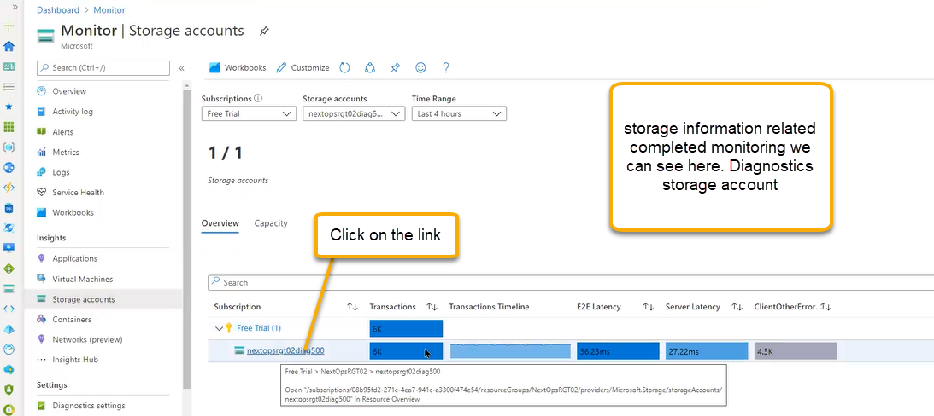

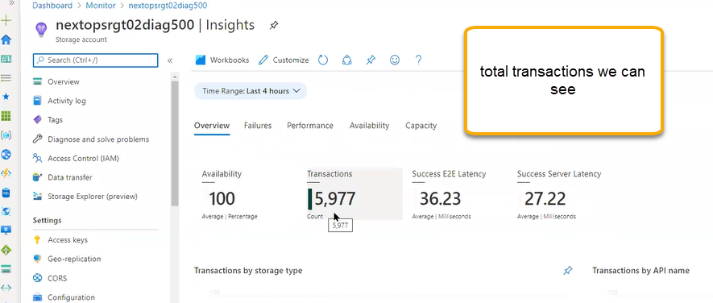

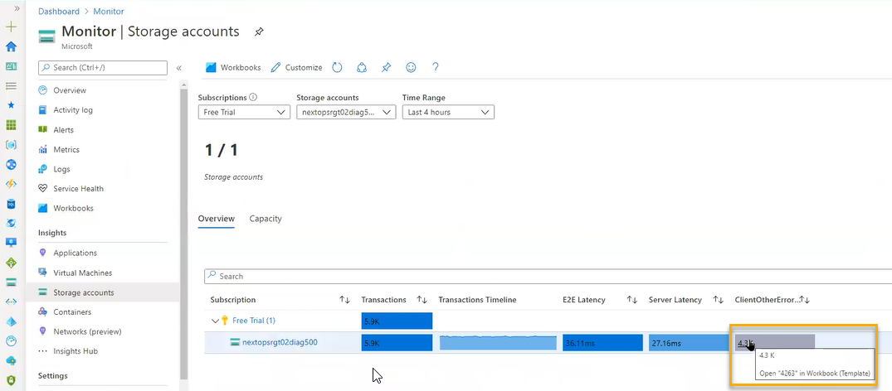

If you click on above highlighted it will navigate to workbook

Containers

In azure we have AKS Azure Kubernetes services to consolidate the docker containers

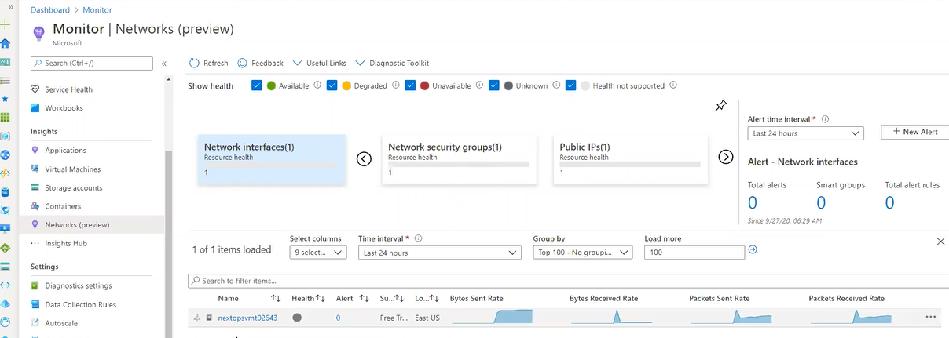

Alerts related to VMS like any bandwidth